State Research
Here are some great resources for you to explore as you investigate your states. Have fun and learn something new!
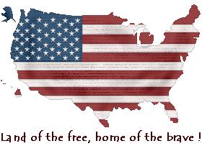

Census Bureau: State Facts  Enchanted Learning  50States.com  America's Story: Explore the States | Infoplease-50 States  State Symbols  The US50.com  Stately Knowledge
State Data Map  State Songs  Make your own state license plate  50 States of the USA  State Poems- state research by students | Factmonster.com/states.html  Netstate.com/states  Culture Grams  (you will need our aea username & password for this site)

Looking for Recipes for your State Menu?
Check out these websites.

American Food Through Regional Cuisine
Northeastern U.S.A Recipes
Northeastern USA Cooking by State
Southern Cooking by State
Midwestern USA Recipes
Mountain West- USA (Southwestern and Rocky Mountain States) Recipes
Pacific West USA Recipes

To figure out the mileage and trip cost to three interesting locations in your chosen state, you will be using MapQuest:
www.mapquest.com/directions/main.adp

